**Software Engineering I**

Course Number: CS 07321 1

Instructor: Dr. Adrian Rusu

**Fall 2014**

**Team #1**

**November 19th, 2014**

**Robo-Ops Competition**

**User Manual**

**NASA/Department of Mechanical Engineering**



**Team Members:**

**Daniel Bittner**

**Edward Carter**

**Jun He**

**Matthew Ng**

**Dakota Pollitt**

**Zhentao Zhong**

**Table of Contents**

**Introduction ...……3**

**I. Accessing Software ...……3**

**II. User PC GUI ...……3**

**III. Initializing Software ...……4**

**IV. Joystick ...……5**

1. **Close Program ...……6**

**Introduction**

This is the official user manual for both the command PC and Rover PC developed for the Robo-Ops competition. This software system was developed with the intention of allowing the Rover driver on the command PC to control the Rover remotely. The software on the command side allows the driver to use a joystick to control the Rover’s forward/backward movements, allow to control the speed of the motors, rotation degrees, turning left/right.

The software on the Rover side allows the Rover to receive commands and perform the commands, sends video feedback to the command side. The GUI of this software will allow the Rover driver to send commands, switch between cameras, and display video feeds from cameras.

1. **Accessing Software**

This software will be saved as an application on the Command PC. To access it, the application will be run and the GUI will open up.

1. **User PC GUI**

The GUI is the main and only visual window. It will allow the user to see and control what is going on. There are 2 main screens located next to each other for viewing 2 cameras at a time. There are 8 buttons to the side of each screen allowing the user to change between each camera for each screen. A connect button is located in the upper right hand corner. This allows the user to create a link between the GUI, joystick, and Rover PC. After clicking the connect button once, it will change into a disconnect button allowing the user to safely disconnect and reconnect everything as needed. At the very bottom of the GUI, there is a text box that will tell the user what is going on. This includes information about connections between Joysticks, Command PC, and RoverPC, as well as what commands are being sent out, and any errors that may occur.

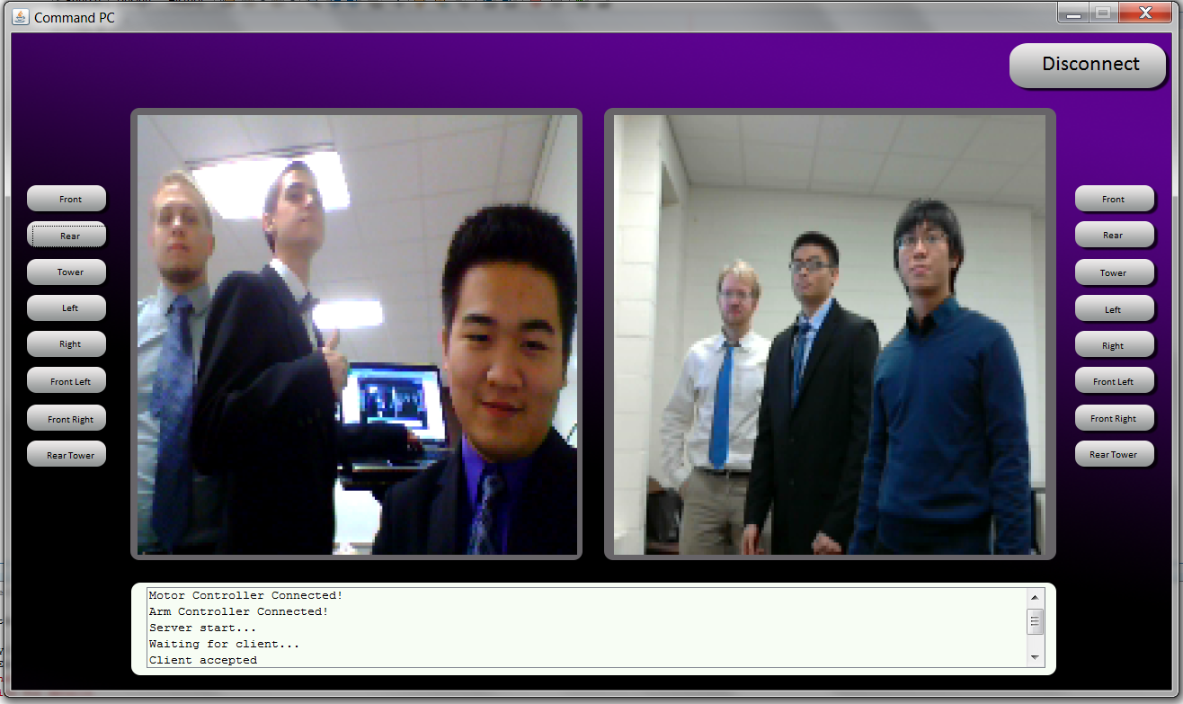

1. **Initializing Software**

Once the software is loaded, the user needs to begin establishing the connection between the command PC software and the rover. The joystick needs to be connected to the computer and the rover needs to be ready to receive the connection. To do so, connect the joystick to the command PC. Then turn on the Rover and initialize the Client software so it can receive commands.

Pressing the CONNECT button on the User PC will allow the software to begin the process of making the connection to the rover. After a brief period, the software will synchronize with the rover and the user will be able to start controlling the rover.

1. **Joystick**

There are 2 separate joysticks to allot for proper control of the Rover movements as well as the Articulating Arm.

The Rover joystick can be rotated 360 degrees allowing it to move in any direction. There is a speed control lever on the left side to decide how quickly the Rover will move.

The Articulating Arm joystick has the same 360 degrees of rotation, but it only controls forward, backward, left, and right. The joystick can be twisted to allow rotation of the shoulder and wrist joints on the arm. Only 1 part of the arm can be controlled at a time. There are multiple buttons located on the joystick to switch between what part of the arm is being controlled. The 1 button switches to claw control, 5 for the shoulder, 6 for elbow, and 7 for wrist. Each joint moves at a preset speed.

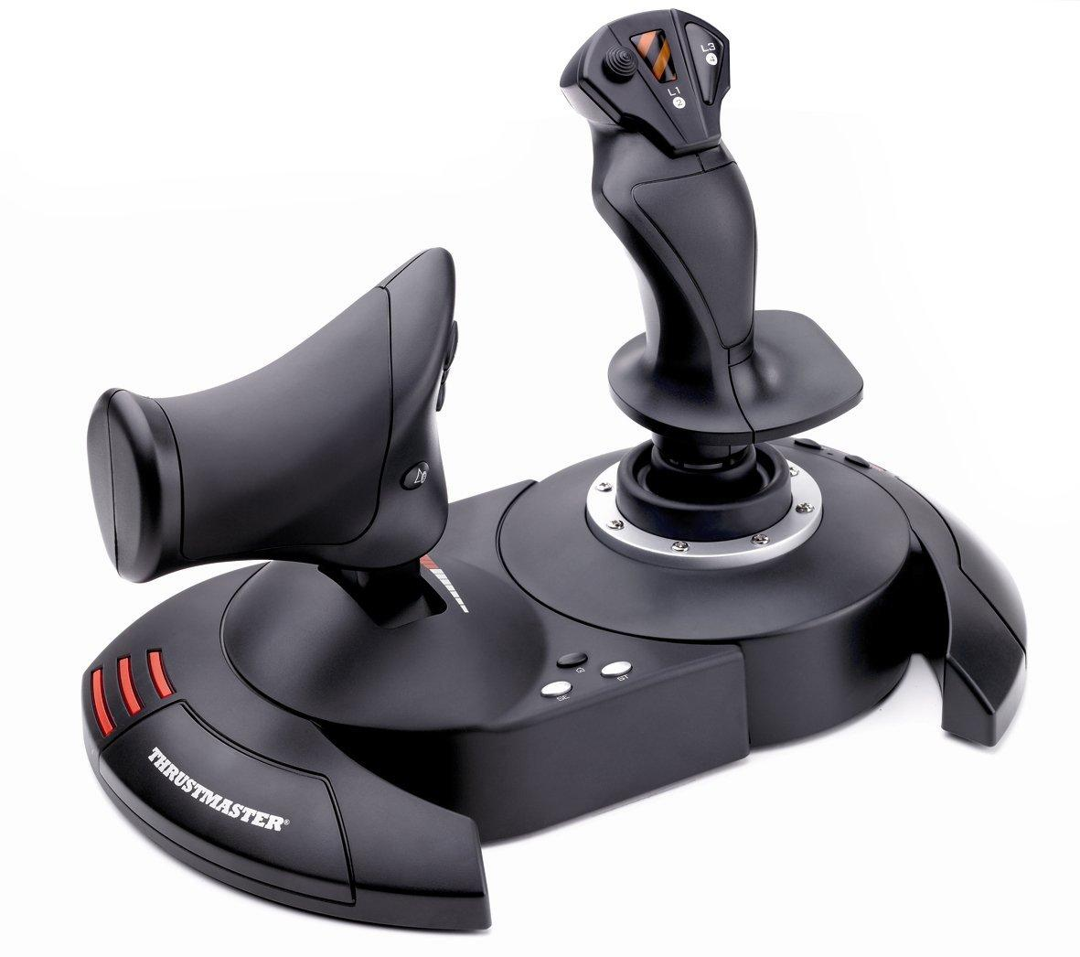

1. **Close Program**

To close the User PC program, just simply press the ***Disconnect*** button located in the upper right hand corner where the ***Connect*** button was. Then click on the ‘***X’*** at the top right corner of the software.

The Rover PC program is closed by simply pressing the ***X*** located in the upper right hand corner of the screen.

Key GUI Features

* + 2 Camera Windows
  + Buttons for Controlling Windows
  + System Status Updates Text Box
  + Joystick and Controller Status Indicator